Automated Elevator with Overload Alert

This system helps to indicate limit of an elevator, which is how many people can be inside an elevator at a particular time. The system displays the number of people inside an elevator with the help of 7 segment display. Each pair consists of 2 sensor pairs placed at a certain distance from one another in the opposite direction. The system includes Infrared Sensor pairs which are placed near the elevator door. These sensors senses when a person enters an elevator and it opens the door of the elevator and simultaneously increments the counter for the number of people entering the elevator. The IR transmitter is used to transmit IR rays straight to the receiver which receives the input and feeds this to an 8051 Microcontroller. The microcontroller process this input received. At this time the system also counts the number of people present and increments a counter on each arrival and decrements when a person exits from the elevator. The system even includes a buzzer for demonstrating an alarm. The buzzer starts ringing as soon as more number of people enters the elevator than the limit of the elevator which is already set and the buzzer stops ringing only when the people inside the elevator come outside the elevator. This will cause the counter to be decremented and the buzzer stops ringing as soon as the counter is less or equal to the limit of the elevator set.

Block Diagram:
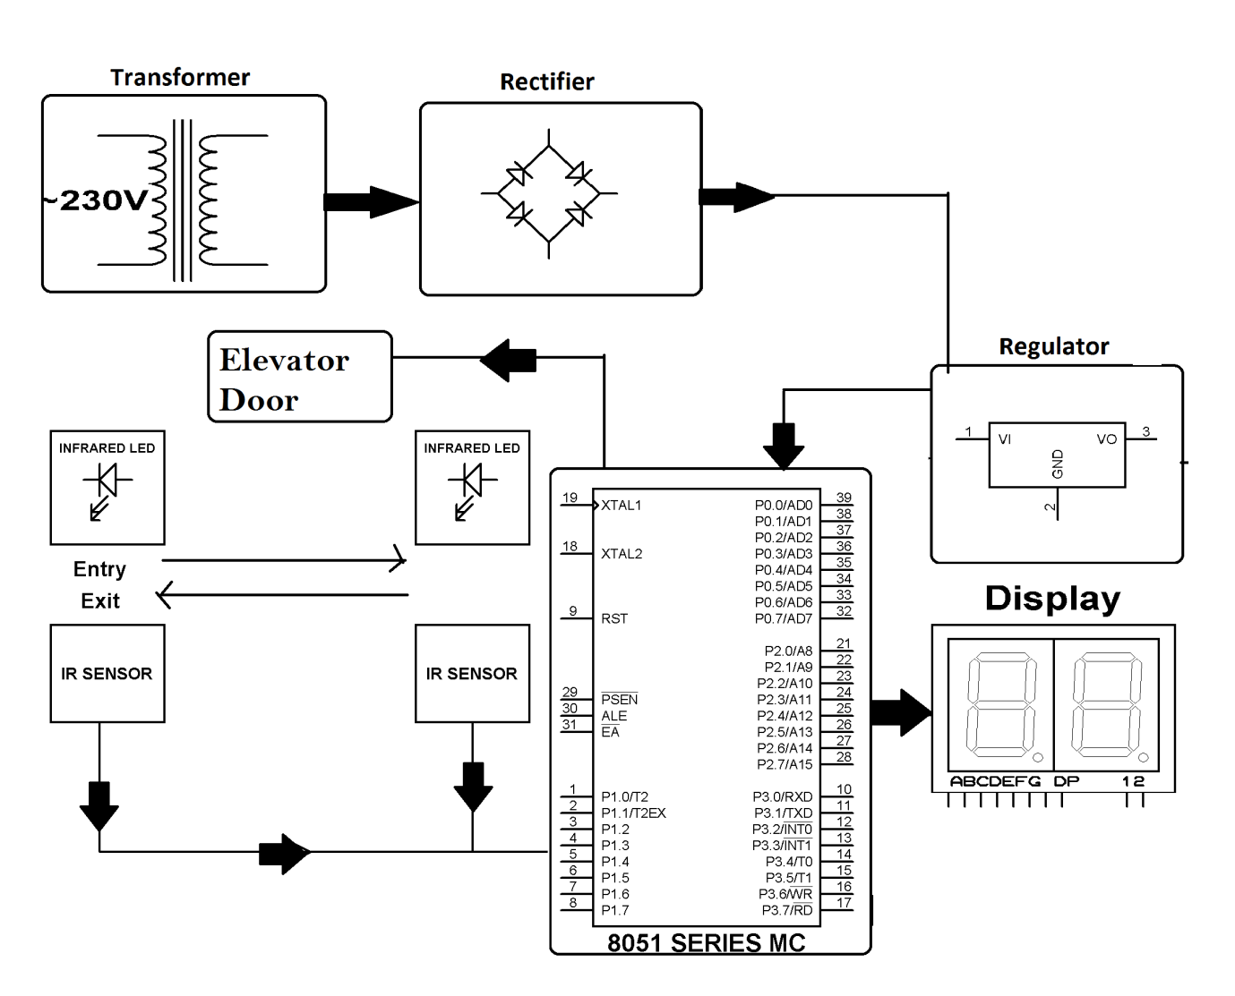

Hardware Specifications:
- 8051 series Microcontroller
- Transistor
- Door
- Voltage Regulator
- IR Receivers
- LED
- Push Button
- Diodes
- IR LED’s
- 7- Segment Displays
- 555 Timers

Software Specifications
- Keil µVision IDE
- MC Programming Language: Embedded C

MICROCONTROLLER DETAILS:

The AT89S52 is a low-power, high-performance CMOS 8-bit microcontroller with 8K bytes of in-system programmable Flash memory. The device is manufactured using Atmel’s high-density nonvolatile memory technology and is compatible with the industry-standard 80C51 instruction set and pinout. The on-chip Flash allows the program memory to be reprogrammed in-system or by a conventional nonvolatile memory programmer. By combining a versatile 8-bit CPU with in-system programmable Flash on a monolithic chip, the Atmel AT89S52 is a powerful microcontroller which provides a highly-flexible and cost-effective solution to many embedded control applications.
The AT89S52 provides the following standard features:

Features
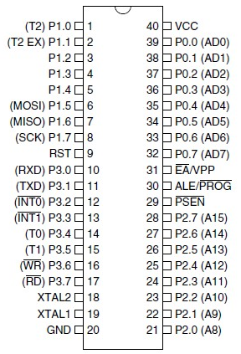
- 8K Bytes of In-System Programmable (ISP) Flash Memory
- Endurance: 10,000 Write/Erase Cycles • 4.0V to 5.5V Operating Range
- Fully Static Operation: 0 Hz to 33 MHz
- Three-level Program Memory Lock
- 256 x 8-bit Internal RAM
- 32 Programmable I/O Lines
- Three 16-bit Timer/Counters
- Eight Interrupt Sources
- Full Duplex UART Serial Channel
- Low-power Idle and Power-down Modes
- Interrupt Recovery from Power-down Mode
- Watchdog Timer
- Dual Data Pointer
- Power-off Flag
- Fast Programming Time
- Flexible ISP Programming (Byte and Page Mode)

Reference

- http://ieeexplore.ieee.org/xpl/articleDetails.jsp?arnumber=7053146&newsearch=true&queryText=elevator%20overload

